Report
China market of water heater

July, 2019

General

China GDP is slowing down, real estate sales is also 6.4% lower than 2018. The percent of clean energy is going higher while coal production is also going higher. As the consumption increase and new energy policy, the gap of supply and demand of natural gas become bigger.

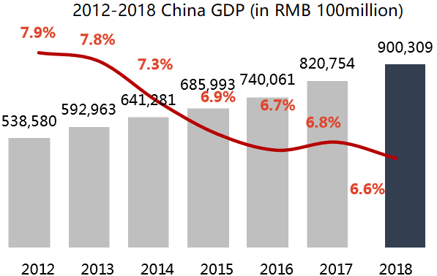
Production Consumption

Increase of energy production & consumption in 2018
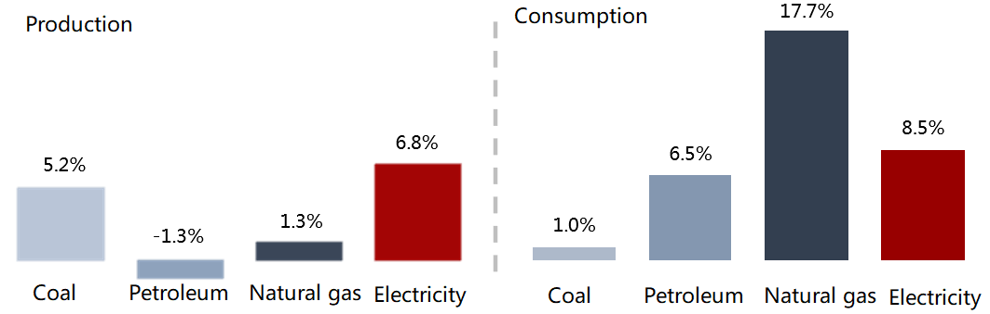

There are 831 million people live in city downtown which is 17.9 million more than 2017; 564 million people live in village which is 12.6 million less than 2017. More people going to smaller towns from big cities because of high living cost in big cities. CPI keep increasing, especially food.
Water heater market

Total sales quantity of water heater decreased in 2018 by 2.7% which is 59.803 million units (also heat pump water heater quantity), sales amount is 59.53 billion RMB which is 1.9% increase than last year.

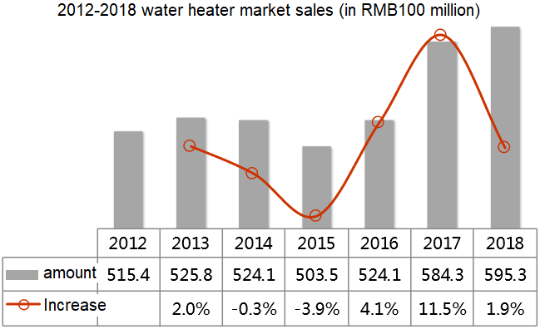

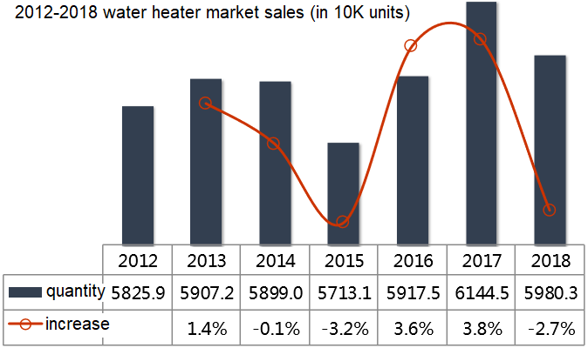

All products quantity is decreasing, especially gas water heater and heat pump water heater which are first time in last 5 years.

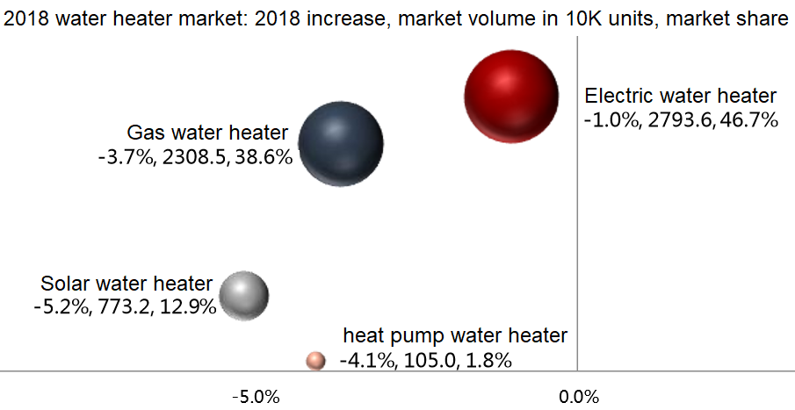

Export of water heater keep stable and solar water heater increase 4.7%, main market of solar water heater is still Mexico, heat pump water heater export is also increasing.

All water heater prices went higher in 2018, especially gas water heater.

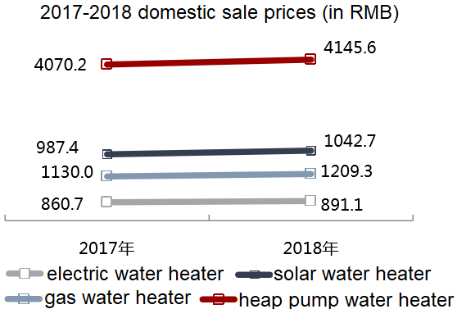

Top players get more market share, especially heater pump water heater.

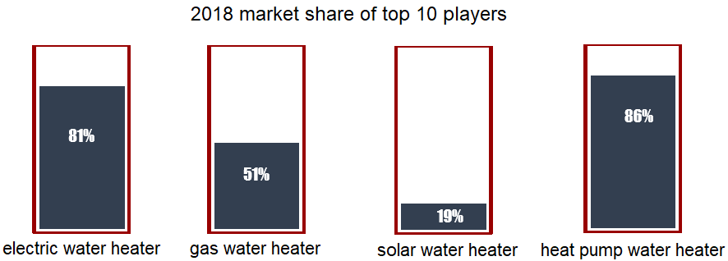
Midea keep the No.1 of business and continue grows, also Haier, Vanward, Wan Jia le (Marco), some foreign brands go down as they focus more on big cities & high end market.

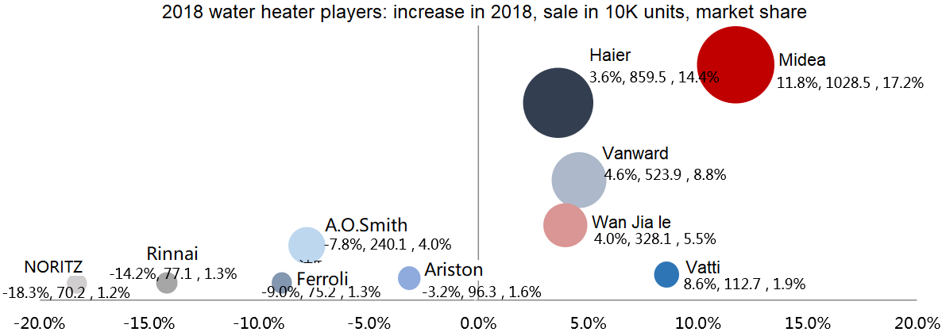

Online sales are keep going higher, especially electric water heater and gas water heater.

Electric water heater

The market is stable & slowing down, 2018 sales amount RMB22.11 billion (2.3% increase), sales quantity 27.94 million units (1% decrease). Online sales is increasing, top players take more market share and new products coming faster, average prices are going up. R&D direction of new products is smart and digital, “Electricity Insulation Wall” become the industry standard, fashion design attract young consumers.

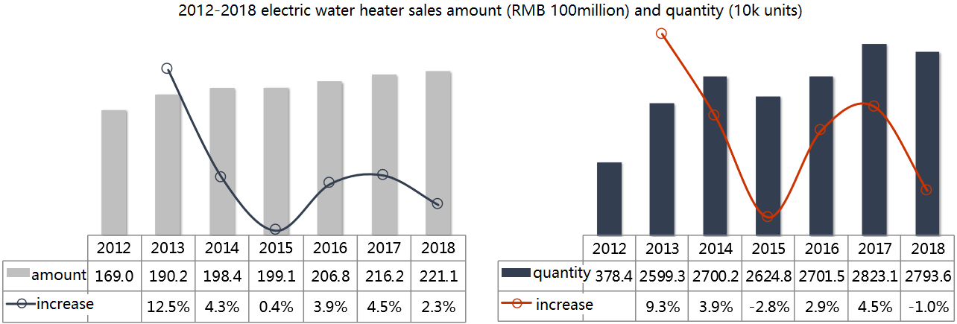

Local market sales 22.92 million units, export 5.02 million units, both decrease than 2017, export market of India, Italy, UAE etc decrease a lot.

Top three players by sales amount are Midea, Haier and A.O.Smith, by quantity are Midea, Haier and Vanward. Midea sub brand: BEVERLY growing fast on offline market. Most foreign brands are decreasing as they focusing on big cities which the real estate market is slowing down.
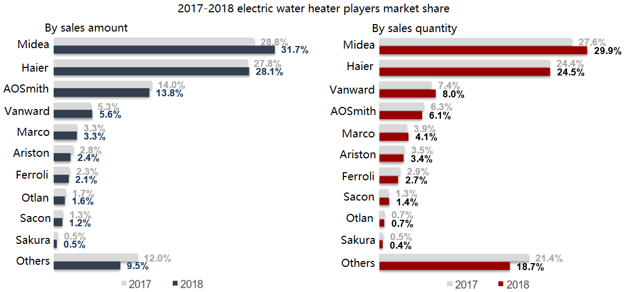

Market share of storage electric water heater keep increasing while instant electric water heater continue decrease. Total sales of instant electric water heater is 308k units in 2018 which is 11.5% less than 2017, Otlan takes about 60% of market share.

Top export players performance:
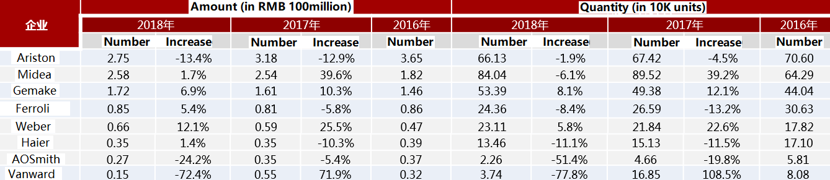

Some export destination countries:
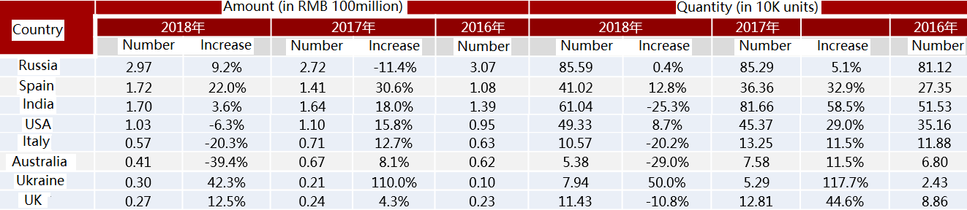

Gas water heater

Gas water heater market decrease in quantity which is first time since last 5 years, main reason is real estate market slowing down and competition of gas boiler. Export has 1% increase, while the local market has 4.7% decrease. Local market sales is still focusing on big cities where gas pipeline are ready. Fashion design is important for young consumers and safety is still the important factor for customers’ choice.
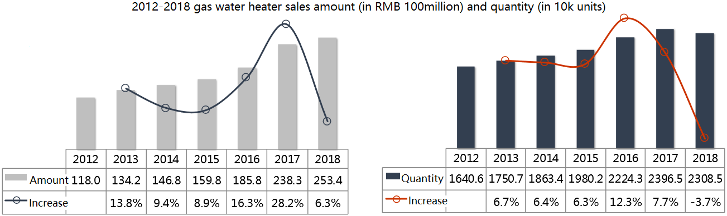

Top players take more market share:

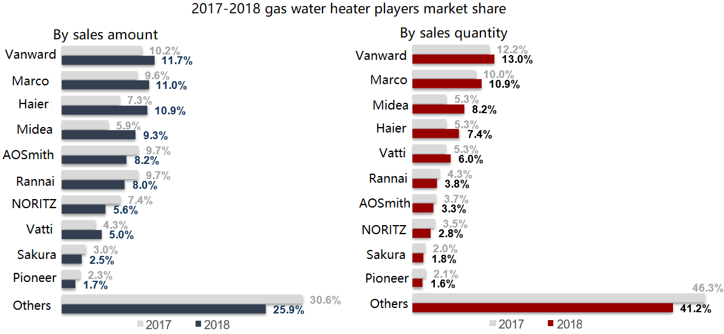

Market share of condensing gas water heater is small (about 6%) but more welcomed by market as energy saving, Vanward still take the No.1 of this market.

Solar water heater

Solar water market continue go down for 5 years, total sales in 2018 is RMB7.3 billion which is 9.2% less than 2017, total sales quantity 7.73 million units which is 5.2% less than 2017. Export is going higher but mainly to Mexico market which take more than 45%.

Heat pump water heater

Heat pump water heater sales amount and quantity are both went down, total sales RMB6.73 billion which is 1% decrease, sales quantity 1.29 million units which is 2.2% decrease. Both local market and export are not well.
Main players:

Midea:
No. 1 of water heater business, turnover of 2018 is RMB 10.6 billion which increase 20.1%, total sales quantity 10.31 million units which increase 11.7%.
Use two heating elements 3000W+2000W in one electric water heater for fast hot water supply and increase the “available capacity”.

Haier:
Turnover of 2018 is RMB10.1 billion which is 14.5% increase, sales quantity 8.67 million units which is 3.9% increase.
Design “fast heat” electric water heater for local market. Also issue “electric insulation wall” water heater to India market as 92% India families has the risk of electricity leakage.

A.O.Smith:
Turnover of 2018 is RMB5.44 billion which is 4% decrease, sales quantity 2.4 million units which is 7.8% decrease.
Focus on fashion design with slim body and fast heat technology. Design silent split heat pump water heater and silent one-body unit heat pump water heater which are the first in market.

Gree:
Turnover of 2018 is RMB1.12 billion, sales quantity 216 thousand units which is 2.7% decrease.

Made by: JRS Components (HK) Limited.
Date: July, 2019

