Inspection Report
Production data
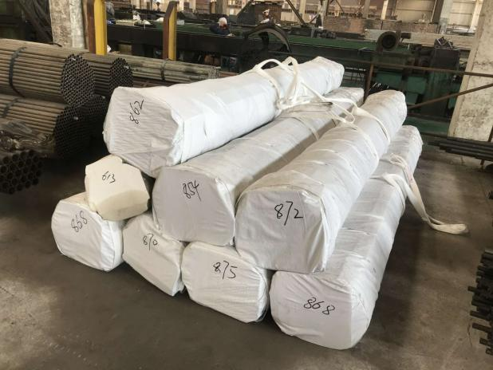 |  | Client:
 |  | Product: |  | Seamless pipes
 |  | Inspection location:
 |  | Inspection date: |  | 2021.04.14
 |  | P/O number:
 |  | Supplier:
 |  | Order quantity:
 |  | Qty ready for inspection:
 |  | Reference sample available: |  | No
 |  | Inspector
 |  | Approved by
OVERALL INSPECTION RESULT |  | Pass

INSPECTION RESULT SUMMARY
Criteria & Norm: 标准与规范: |  |  | Drawings (see the last sheet as attached) EN10305-1
Updates & Changes: 更新和更改: |  |  | No
Remarks of last inspection: 上一次检验备注： |  |  | No
Daily first article checking: 日常首件检验： |  |  | OK
Daily last article checking / 日常尾件检验 |  |  | OK
《Quality problems happened》 checking / 历史质量问题确认 |  |  | OK

INSPECTION RESULT SUMMARY
 | Result | Findings/Remarks
Appearance | OK
TESTS | OK
QUANTITY | OK
PRODUCT COLOR | OK
PRODUCT DIMENSIONS | OK
SHIPPING MARKS | OK
OTHER REMARKS
We have participated in part of the production process and completed the inspection

PO | Code | Order QTY | Available QTY | Inspected QTY | Qualified QTY | Defective QTY | Result
1402213 | 21*16*2.5mm | 3750pcs | 3750pcs | 200pcs | 197pcs | 3pcs | PASS
Total |  | 3750pcs
Overall inspection result
Overall Inspection Result: | PASS | To client requirements
AQL Inspection details
Inspection performed per : | ANSI/ASQ Z1.4-2003/ISO 2859-I〔1999〕  Single Sampling size | Table | I | Level | Ⅱ
Inspection performed per : | ANSI/ASQ Z1.4-2003/ISO 2859-I〔1999〕  Single Sampling size | Inspection | Normal | Table | ⅡA
Sample size | 200PCS |  | Critical | Major | Minor
Sample size |  |  | No allowed | 0.65 | 1.5
Appearance and dimension measurement- Defects findings
Reference No | Defects Description | Cri | Maj | Min
21*16*2.5mm | Dirty |  |  | 3
 | Total defect found: |  |  | 3
 | Number of defects allowed : |  | 3 | 7
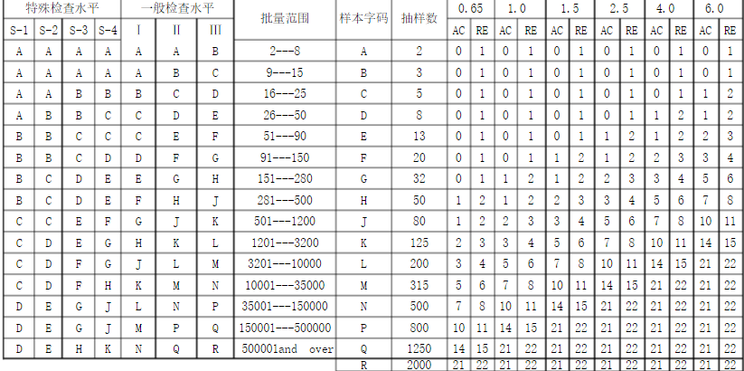

生产流程检查（Production process inspection）
1.冷拔 （cold-drawing）
 | 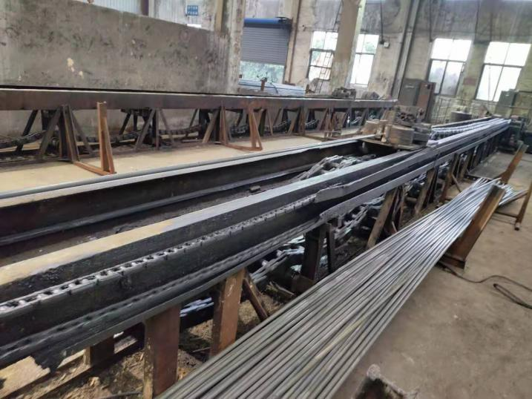
2.热处理（Heat treatment）
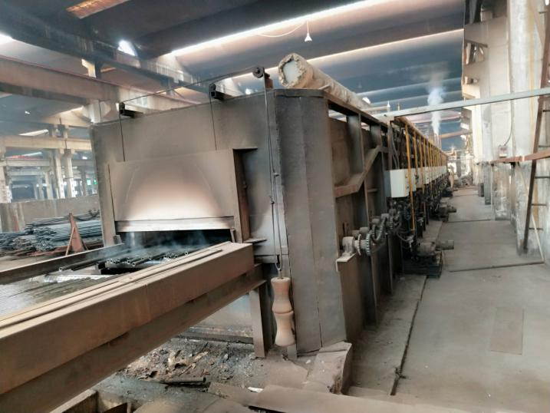 | 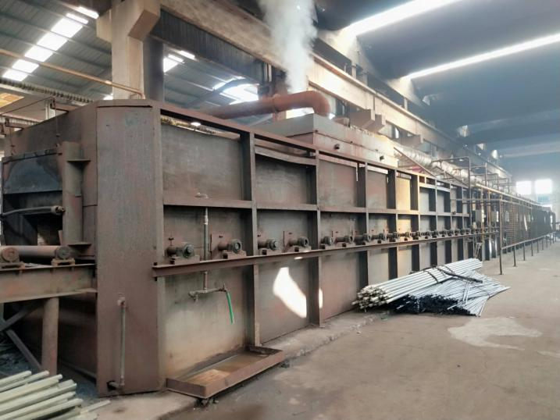
3.测试硬度（Hardness test）
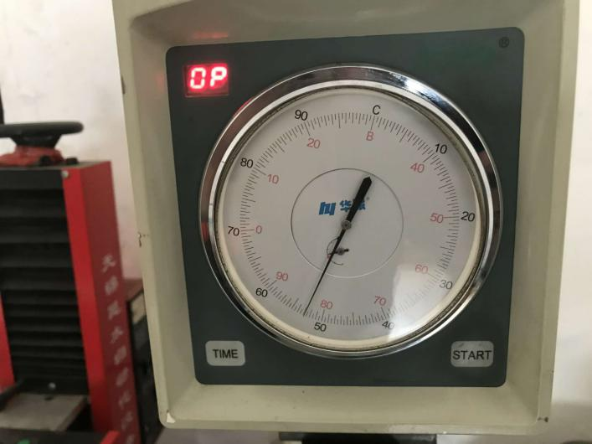 | 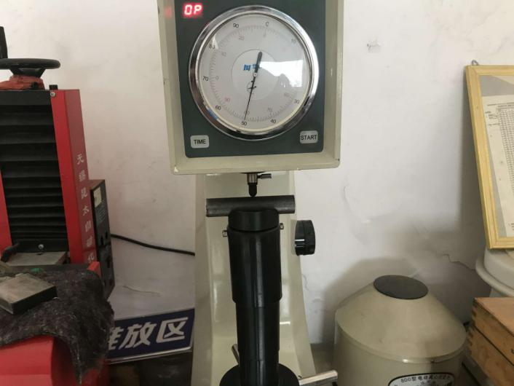
Requirement：HRB 80——84
Real size: 82.5 ，83， 83， 82， 83.5
3.矫直（Straightening） twice
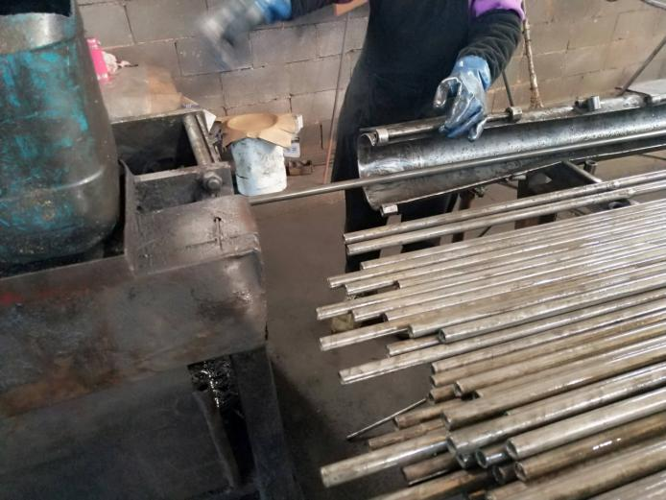 | 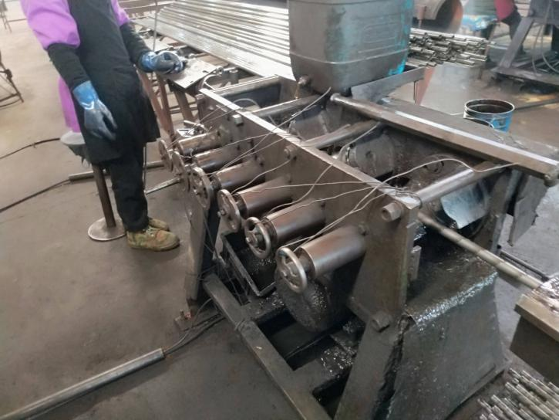
4.切头尾（ cutting ends）
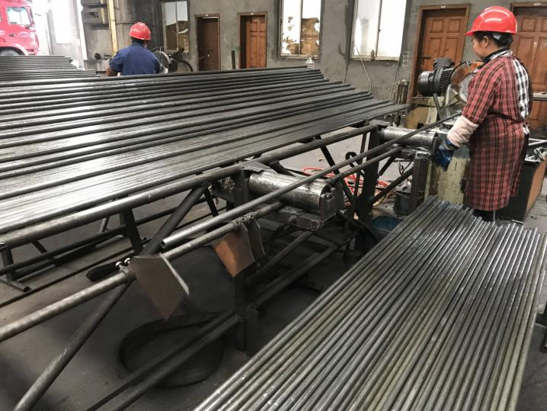 | 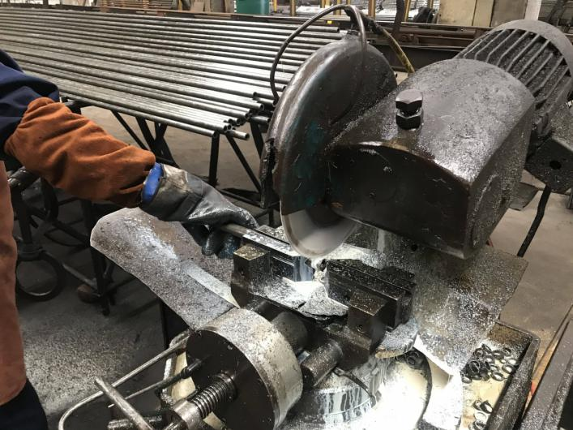
Dimension limit baffle
5.去毛刺（ deburring）
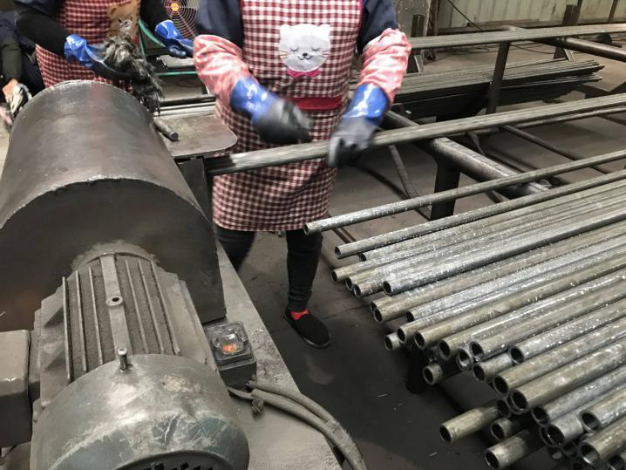 | 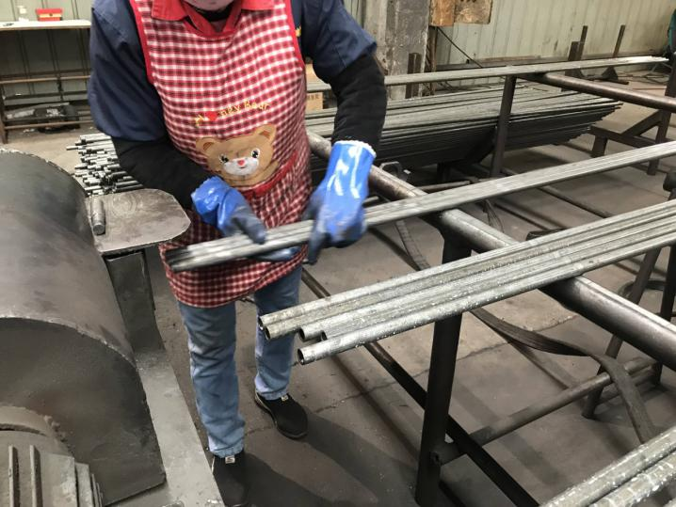
5.尺寸检验（Size examination）
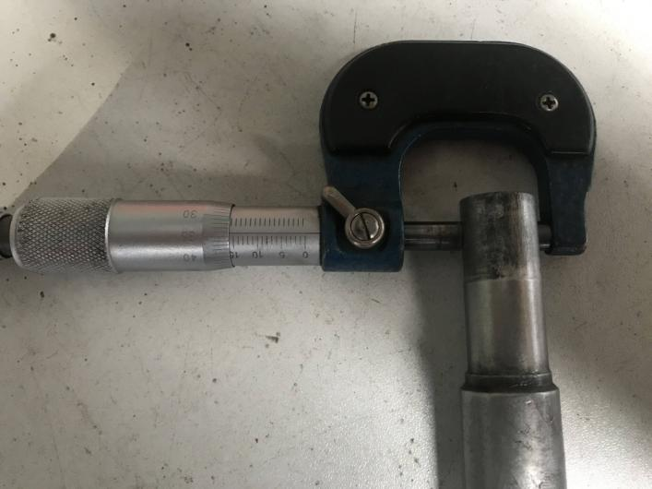 | 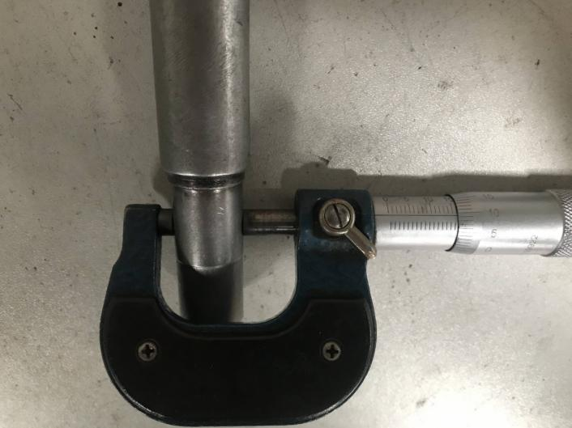
The test equipment Gauge ф15.85mm | Check gauge ф16.15mm
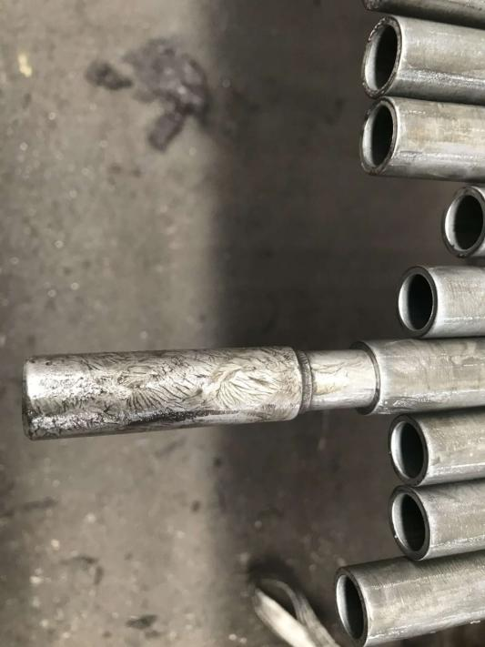 | 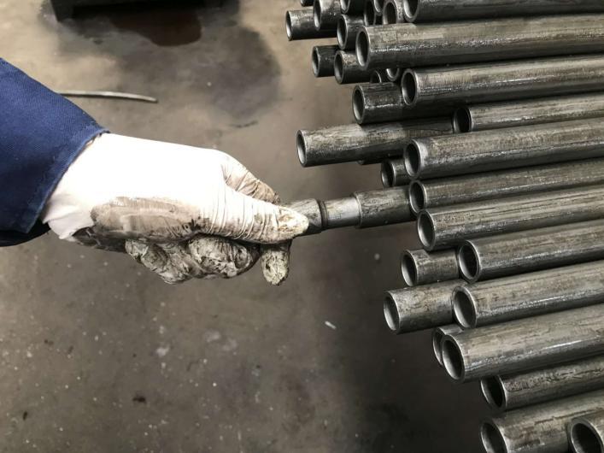
Request(16±0.15mm) is:OK
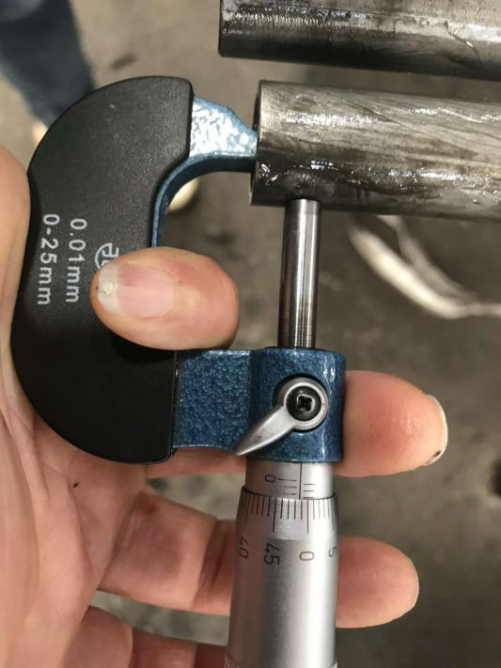 | 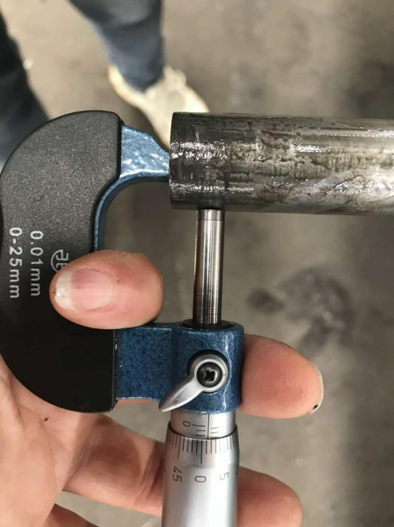
Wall thickness 2.49mm:2.50mm;2.48mm;2.51mm;2.51mm;2.50mm
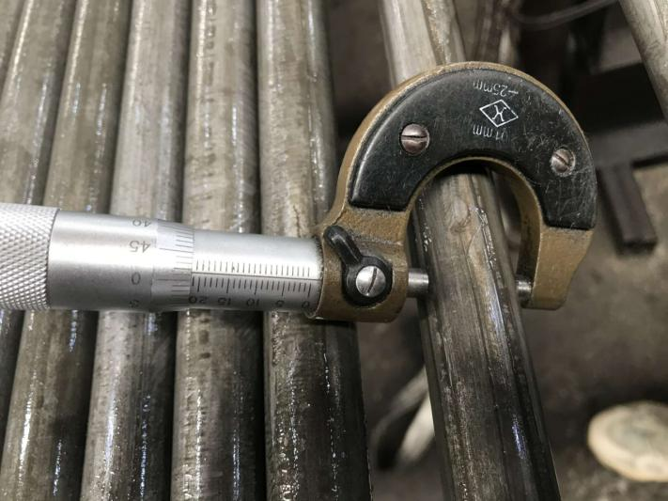 | 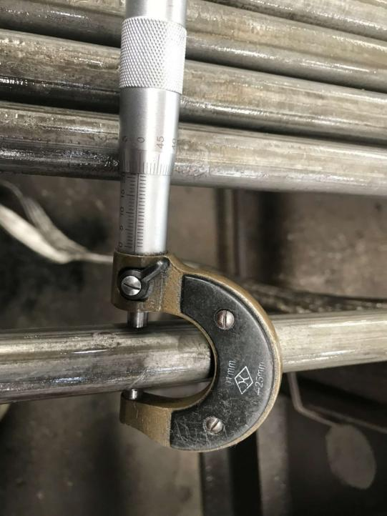
Request(21±0.08mm) 20.98mm;21.00mm;21.02mm;21.01mm,21.03mm
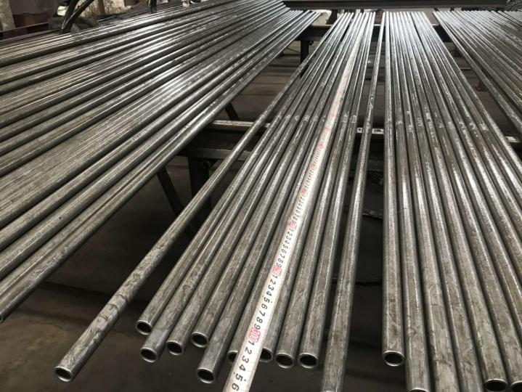 | 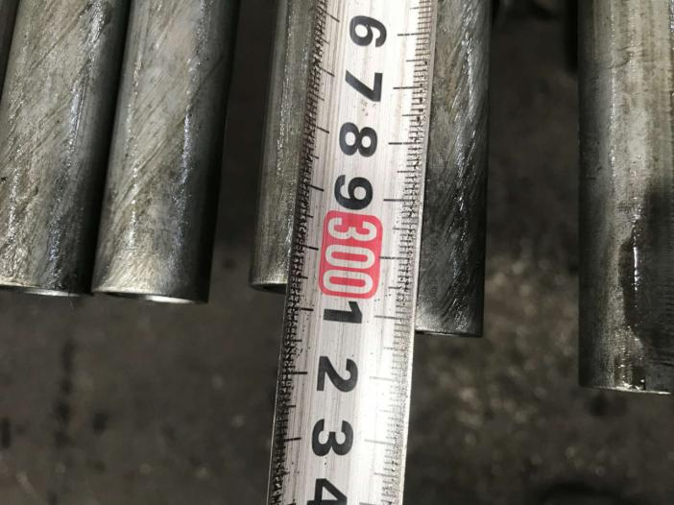
Request(3000mm)：3005，3010，3014，3012，3013，mm
6.外观检查（Sursace examination）
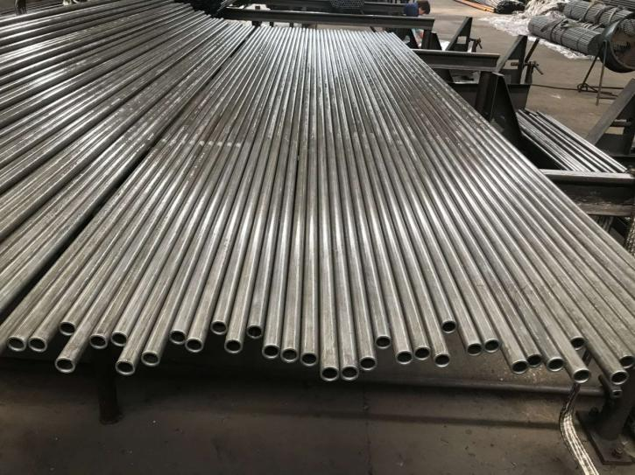 | 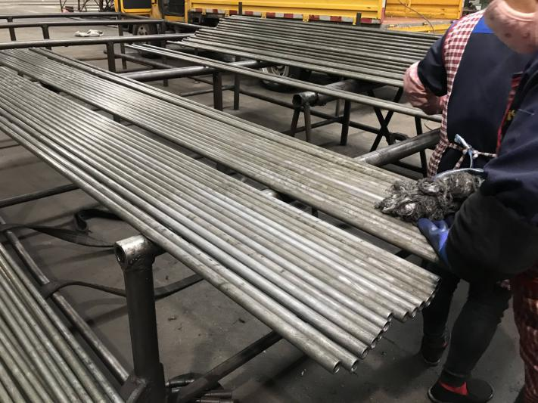
Clean up the dirt on the surface
7.涂油（Coating）
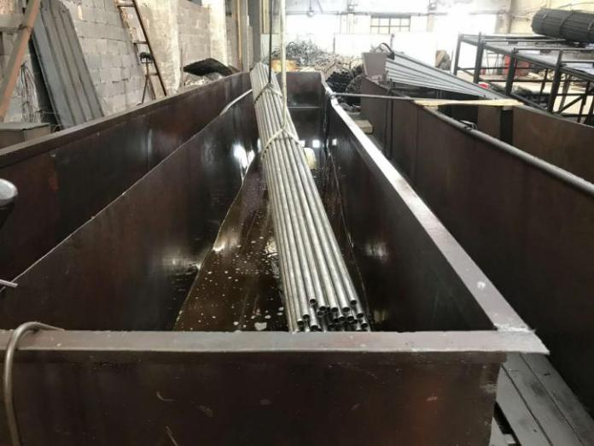 | 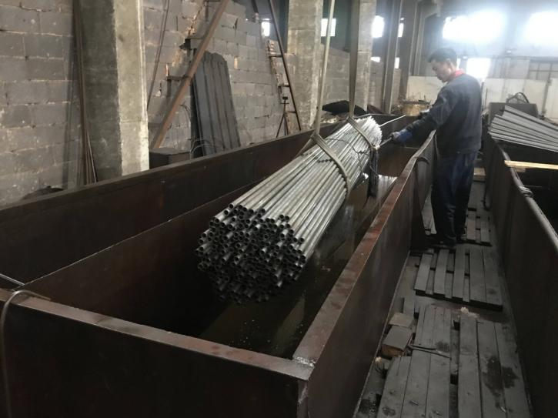
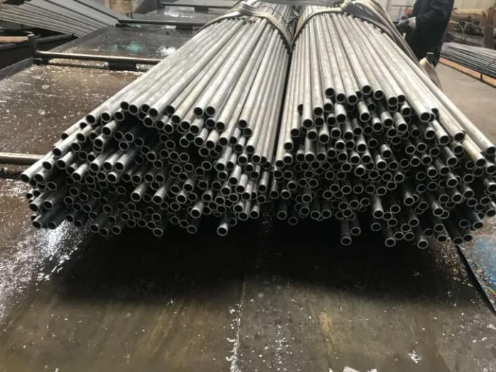 | 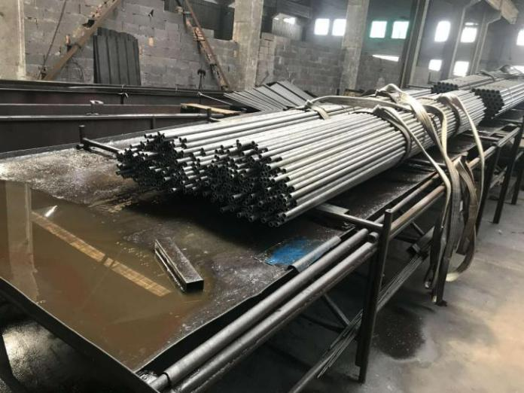
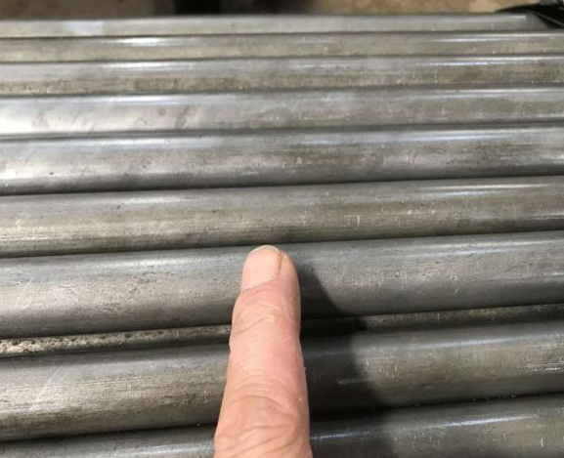 | 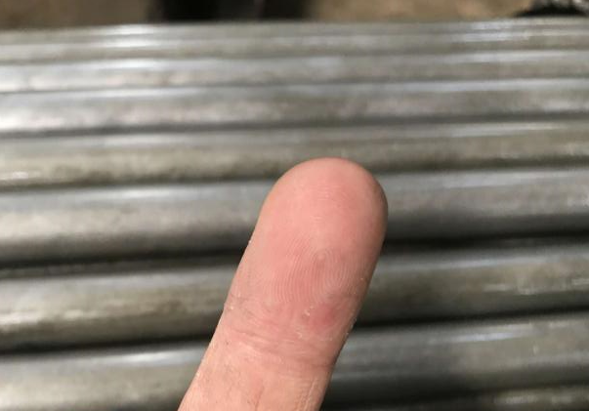
There is not much residual grease on the surface
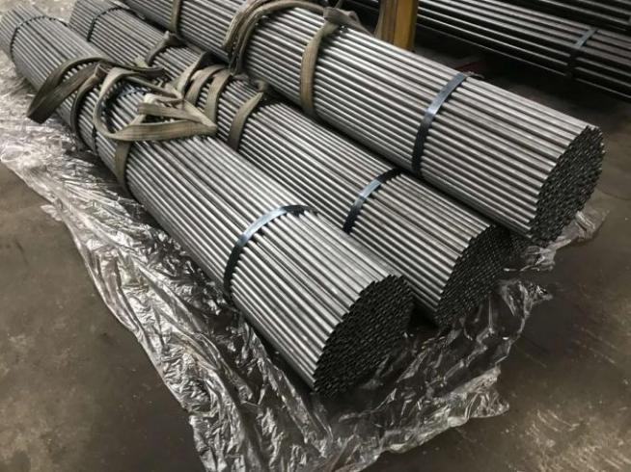 | 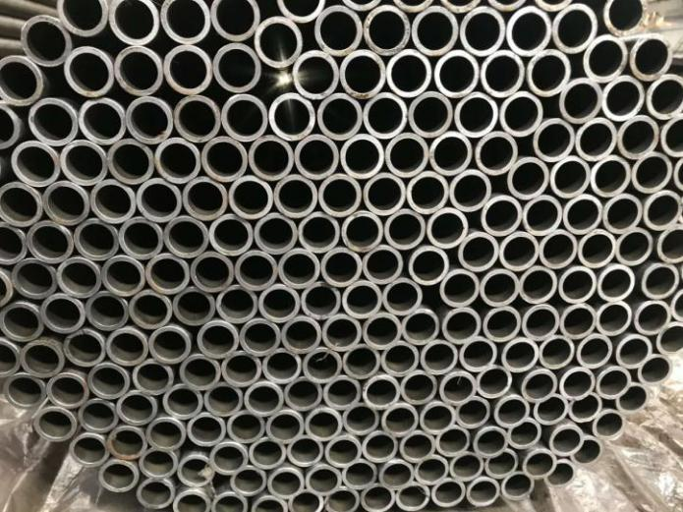
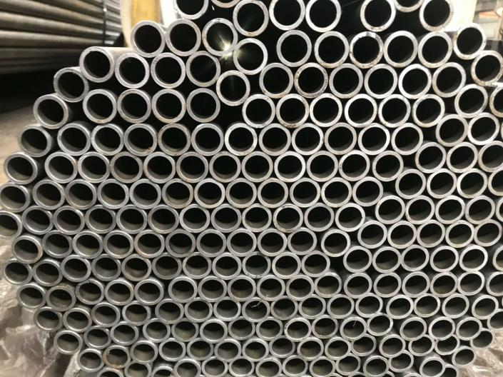 | 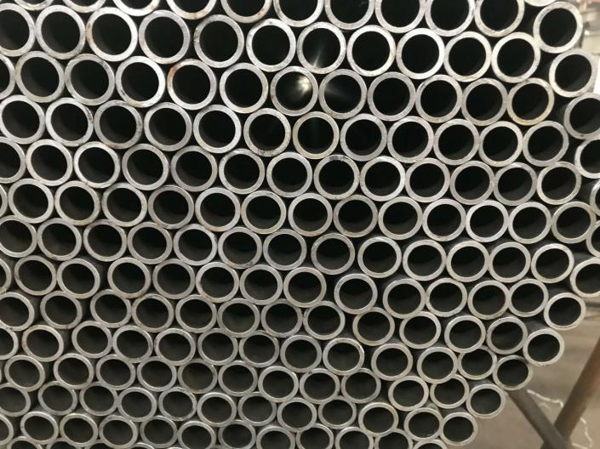
Burr is: OK
8.包装（Packing）
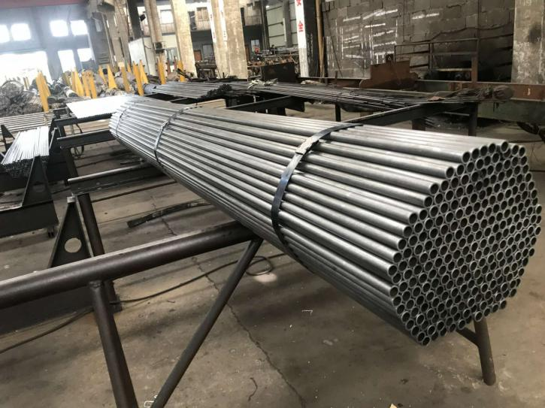 | 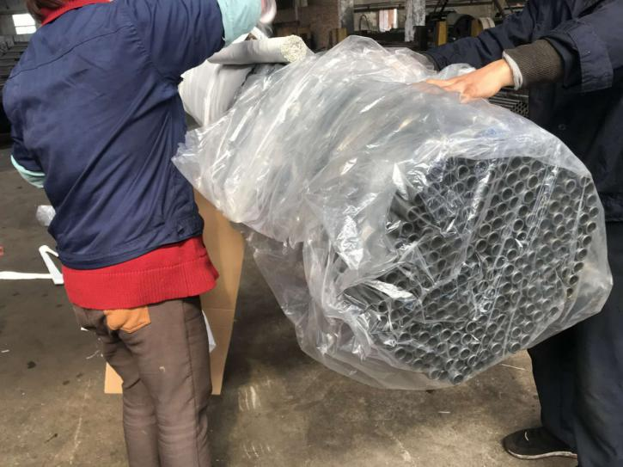
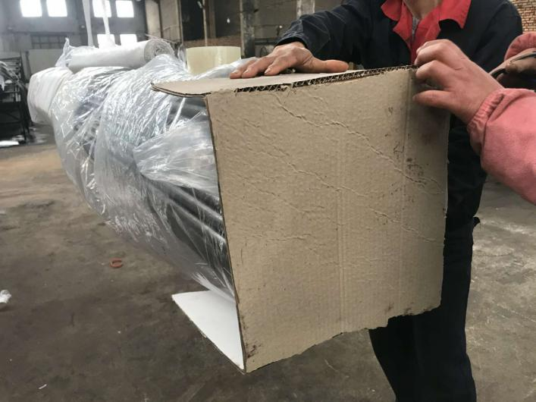 | 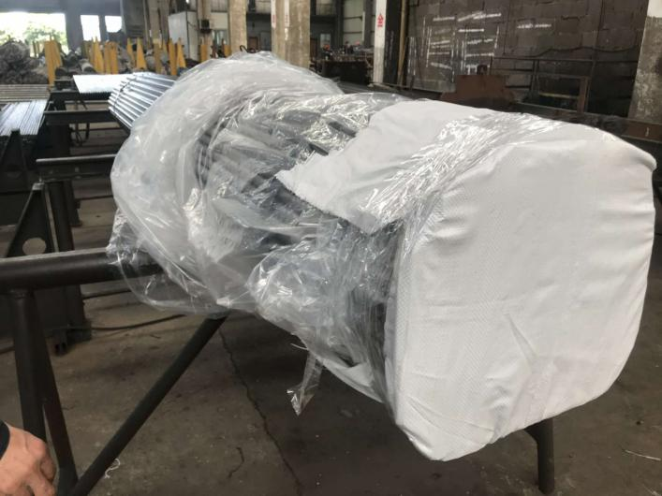
250PCS/package
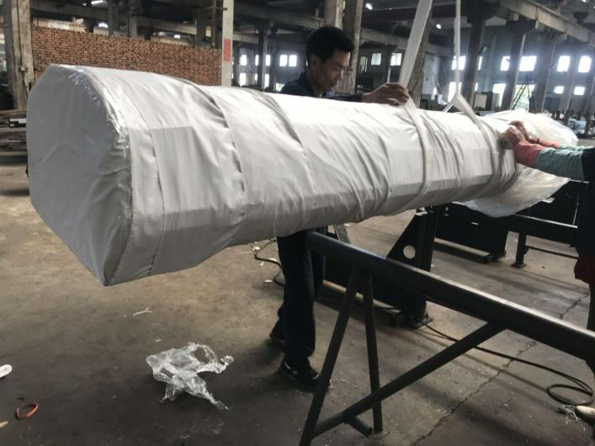 | 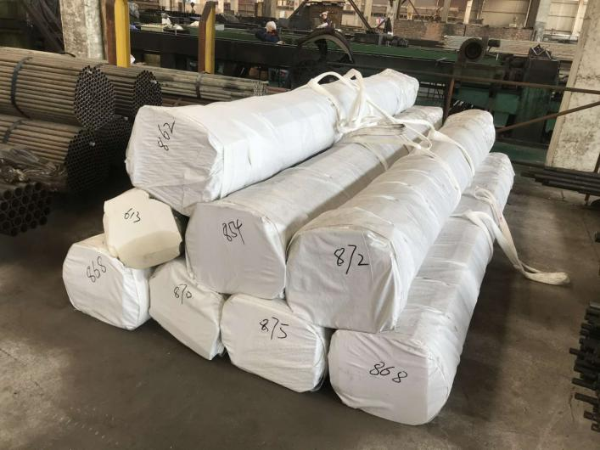
A：车削螺纹测试 （Thread cutting test）
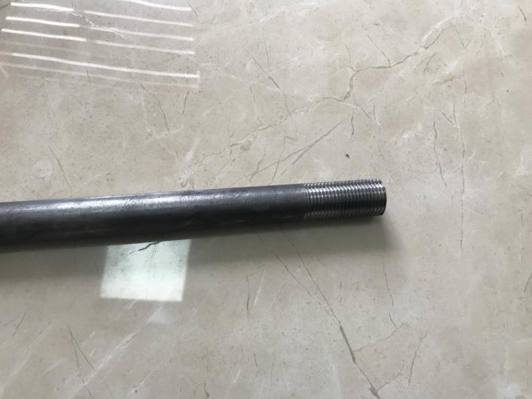 | 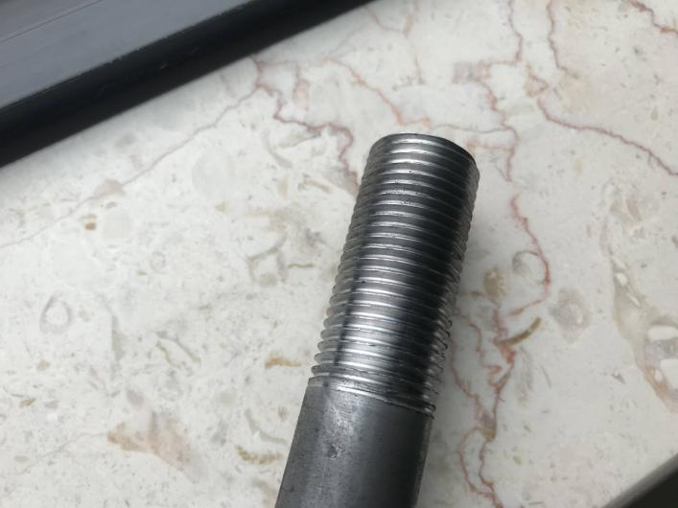
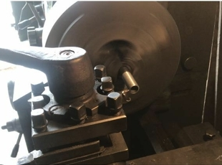
Thread ：OK
B:机械性能测试(Mechanical performance test)
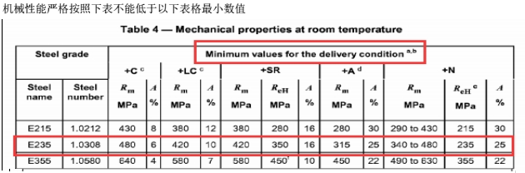
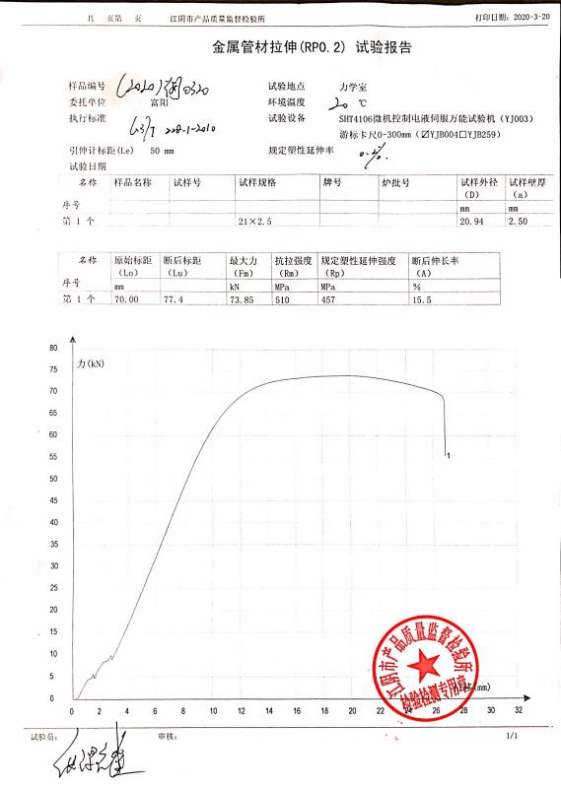
test results： OK
C:.原材料成份(Raw material composition)
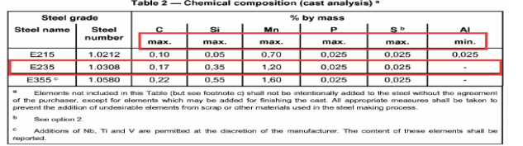
Standard requirement | test results： OK
Ingredient reports provided by raw material steel suppliers
D:.工厂质量保证书（Factory quality inspection report）

End of the report

