Inspection report of power cables sample
Production data
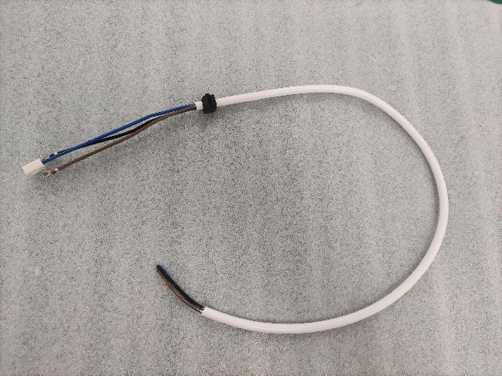 | Client name
 | Product Name: | Power cable
 | Inspection location:
 | Inspection date: | 2022.08.05
 | P/O number: | Please see the list below
 | Supplier:
 | Order quantity: | Please see the list below
 | Qty ready for inspection: | Please see the list below
 | Reference sample available:
 | Inspector
 | Approved by
OVERALL INSPECTION RESULT | PASS
Criteria&Norm:  标准与规范: | Drawings (please see the last page)
Updates&Changes:  更新和更改: | N/A
Remarks of last inspection:  上一次检验备注： | N/A
Daily first article checking:  日常首件检验： | N/A

INSPECTION RESULT SUMMARY
 | Result | Findings/Remarks
Appearance | OK
TESTS | OK
QUANTITY | OK
PRODUCT COLOR | OK
PRODUCT DIMENSIONS | OK
SHIPPING MARKS | OK
OTHER REMARKS

PO No. | Code | Order QTY | Available QTY | Inspected QTY | Qualified QTY | Defective QTY | Result
 |  | 23pcs | 23pcs | 5pcs | 0 | 0 | PASS
 |  | 23pcs | 23pcs | 5pcs | 0 | 0 | PASS
 |  | 23pcs | 23pcs | 5pcs | 0 | 0 | PASS
Overall inspection result
Overall Inspection Result : | PASS | To clients requirements
AQL Inspection details
Inspection performed per : | ANSI/ASQ Z1.4-2003/ISO 2859-I〔1999〕  Single Sampling size | Table | I | Level | Ⅱ
 |  | Inspection | Normal | Table | ⅡA
Sample size | 5+5+5pcs |  | Critical | Major | Minor
 |  |  | No allowed | 0.65 | 1.5
Appearance and dimension measurement- Defects findings
Reference No | Defects Description | Cri | Maj | Min
 | Di |  | 0 | 0
 | Total defect found: |  | 0 | 0
 | Number of defects allowed: |  | 0 | 0
 | Di |  | 0 | 0
 | Total defect found: |  | 0 | 0
 | Number of defects allowed: |  | 0 | 0
 | Di |  | 0 | 0
 | Total defect found: |  | 0 | 0
 | Number of defects allowed: |  | 0 | 0

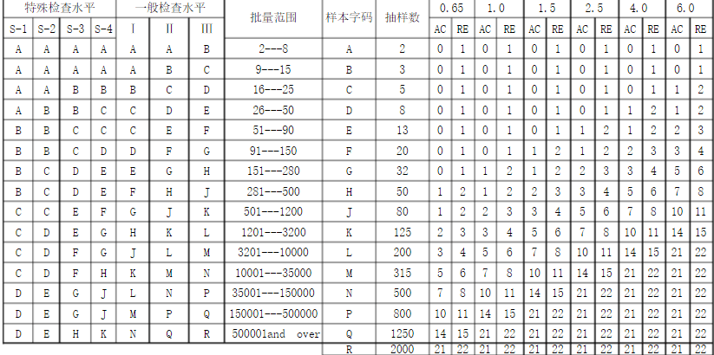

Inspections
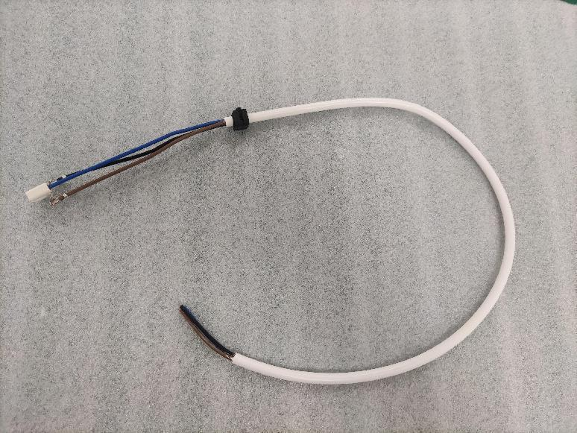 |  | 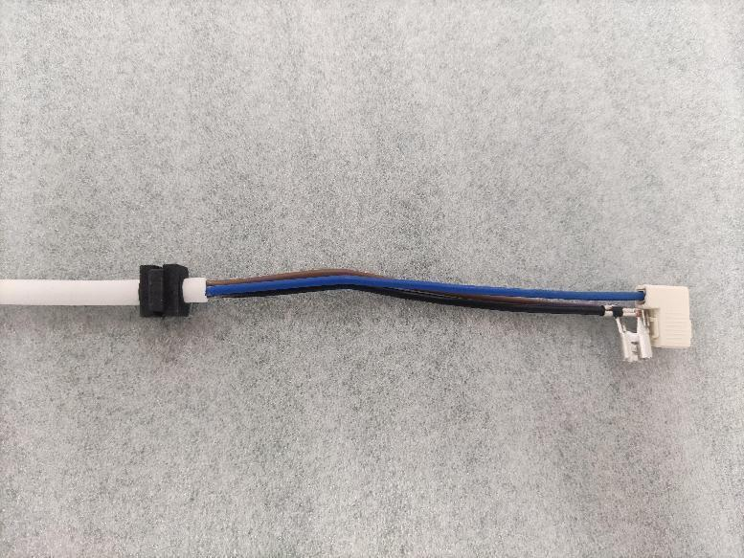
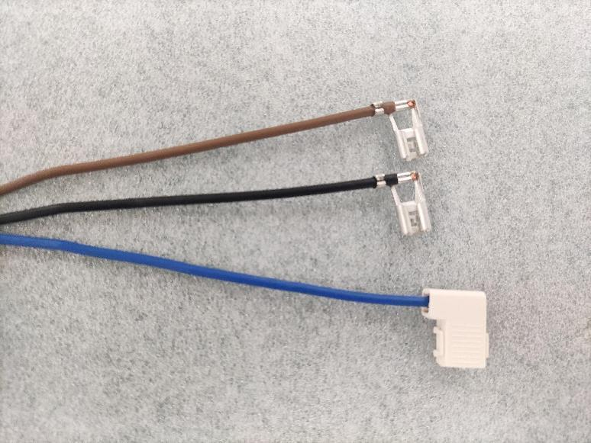 |  | 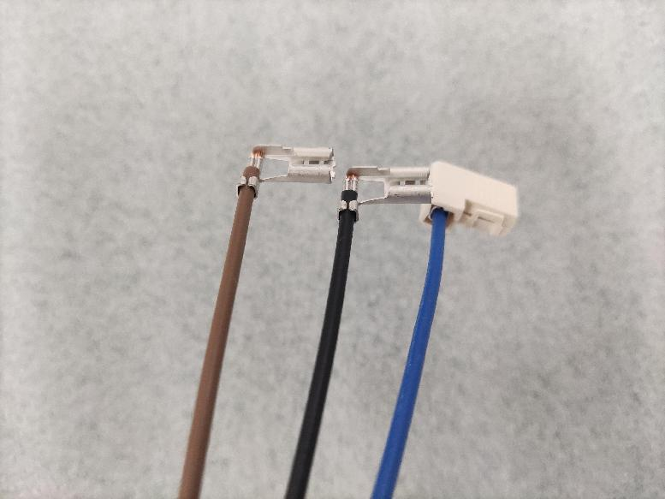
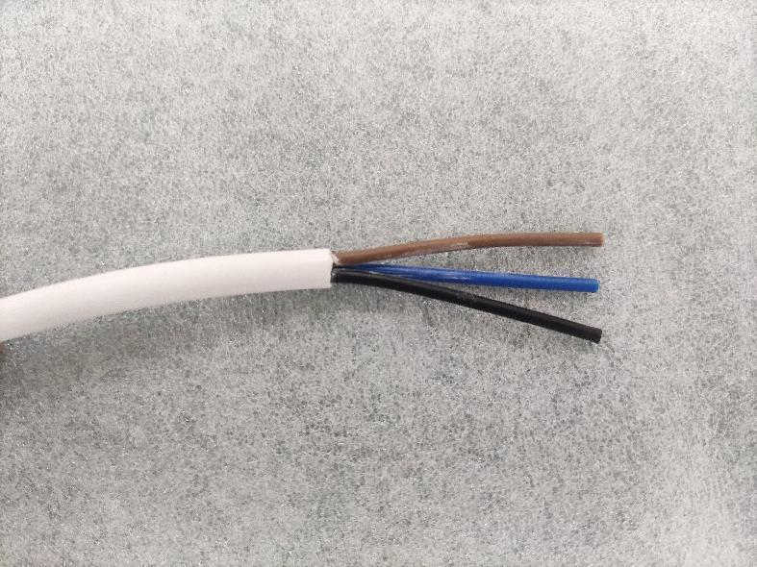 |  | 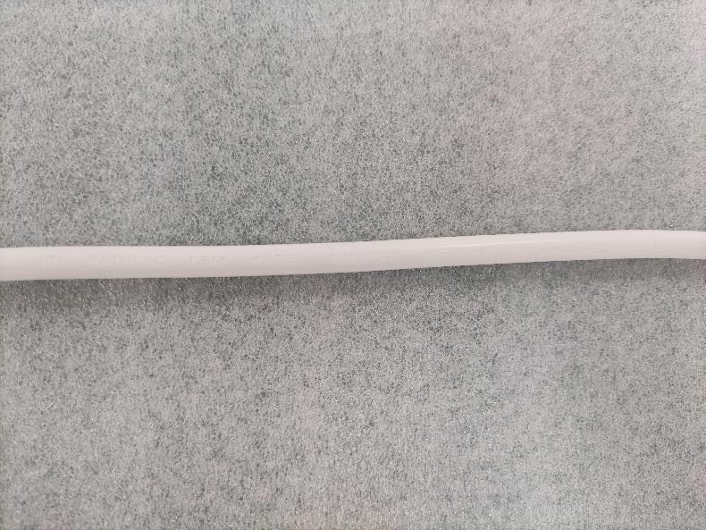
(8) <VDE> N/14750
H05VV-F 3X1mm² IEC 60227
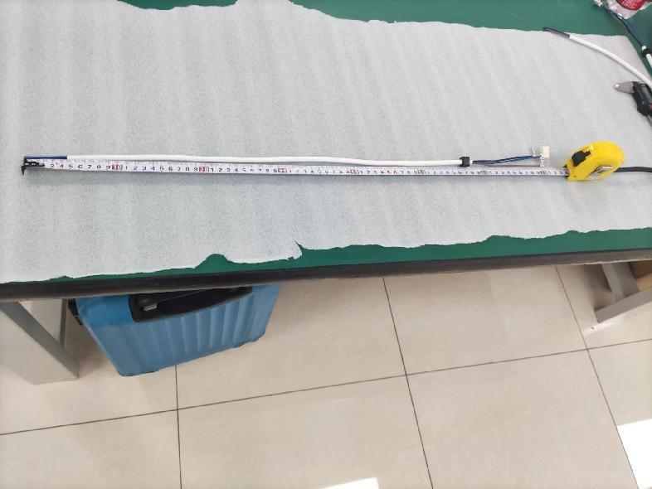 |  | 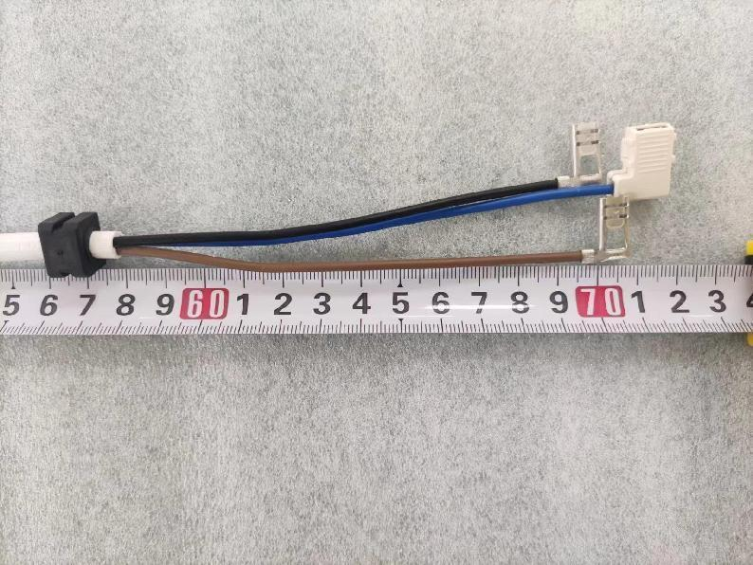
Drawing requirement：700+15/-0mm
Real size: 708 ; 709 ; 708 ; 710 ; 709mm
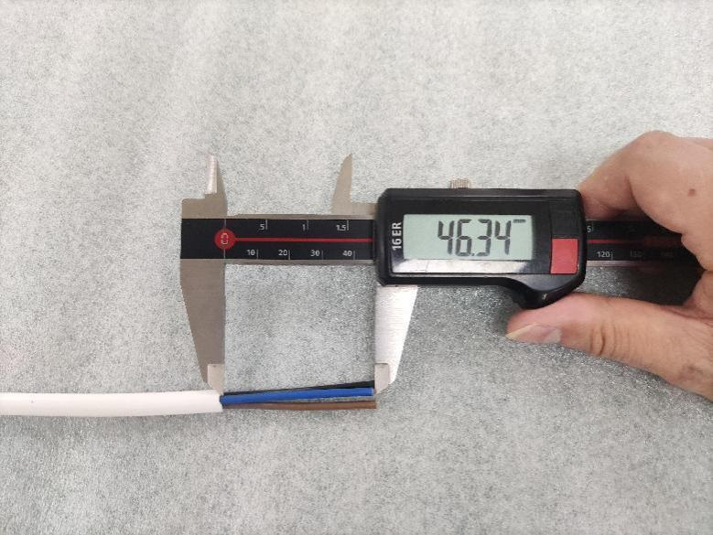 |  | 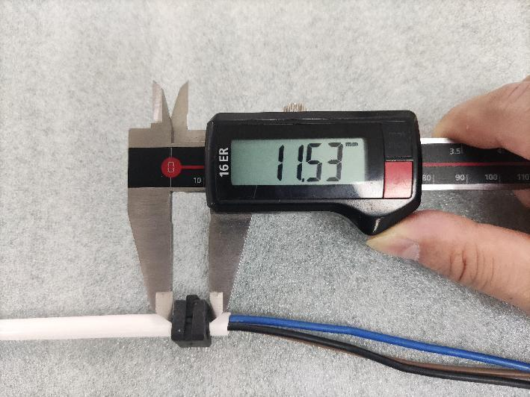
Drawing requirement：50±4mm  Real size: 46.34 ; 46.75 ; 46.69 ; 46.58 ; 46.30mm |  | Drawing requirement：11.5mm  Real size: 11.53 ; 11.52 ; 11.55 ; 11.53 ; 11.51mm
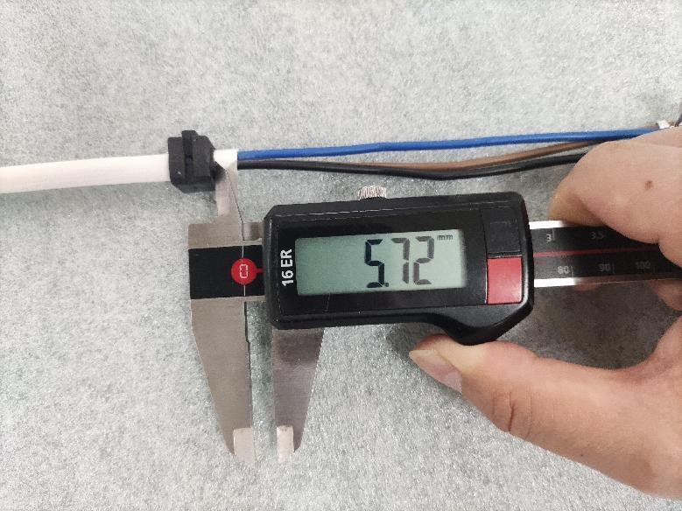 |  | 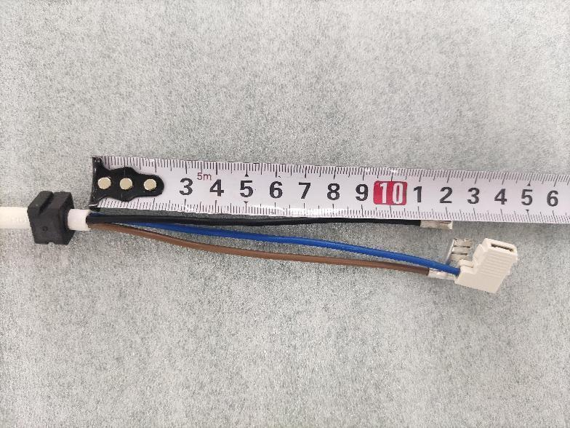
Drawing requirement：8+0/-3mm  Real size: 5.72 ; 5.75 ; 6.03 ; 5.98 ; 6.01mm |  | Drawing requirement：124±4mm  Real size: 122 ; 123 ; 122 ; 123 ; 124mm
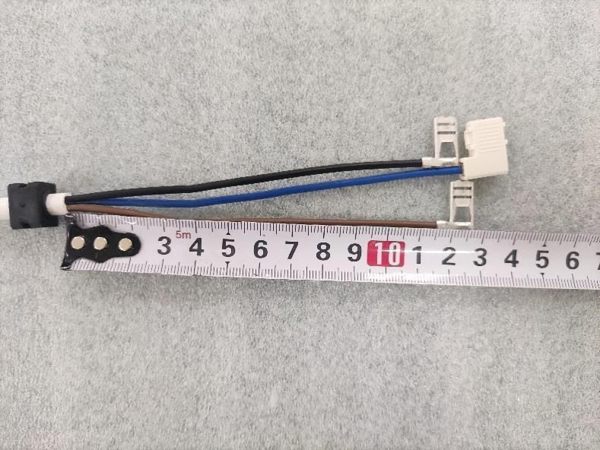 |  | 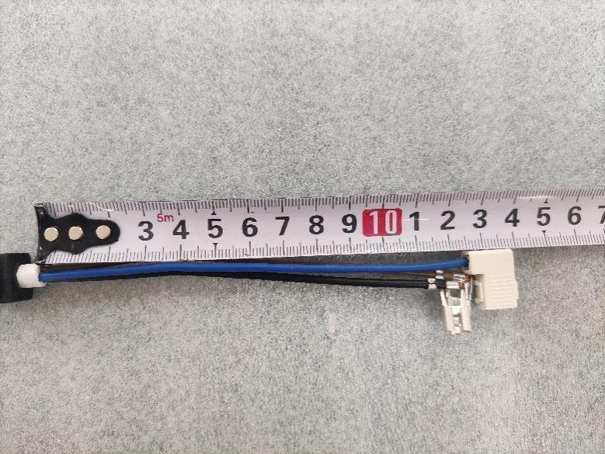
Drawing requirement：130±4mm  Real size: 128 ; 127 ; 129 ; 128 ; 129mm |  | Drawing requirement：140±4mm  Real size: 139 ; 138 ; 139 ; 140 ; 139mm
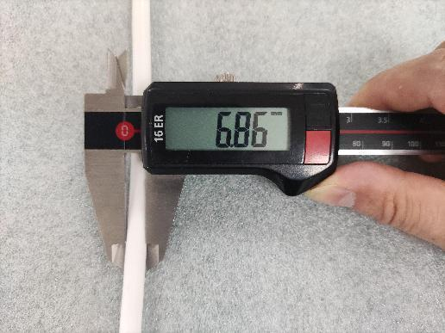 | 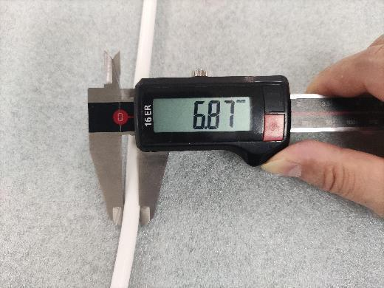 |  | 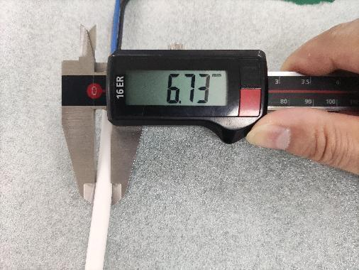
Drawing requirement：6.8±0.1mm
Real size: 6.86 ; 6.87 ; 6.73 ; 6.73 ; 6.85mm
(The same point) Ovality%=(Max OD-Min OD)/Nominal OD*100,must be ≤15% :
Ovality% =(6.83-6.73)/6.8*100=1.47% OK
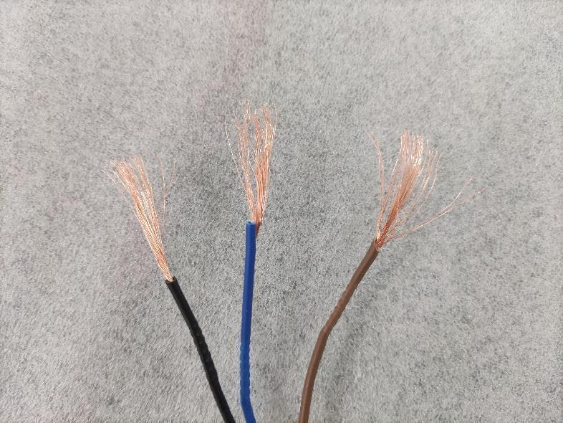 |  | 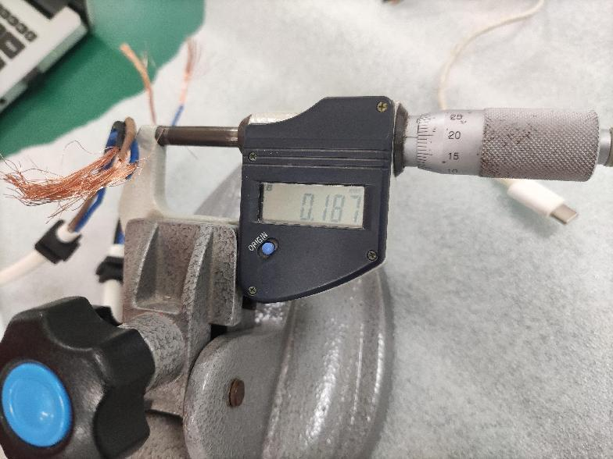
No oxidation (32pcs copper wire) |  | Real size：0.187mm
Hoisting test
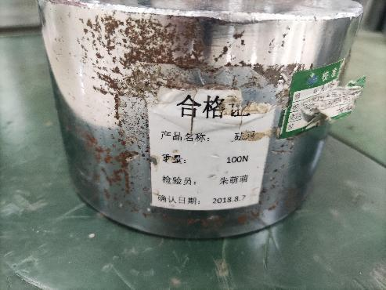 | 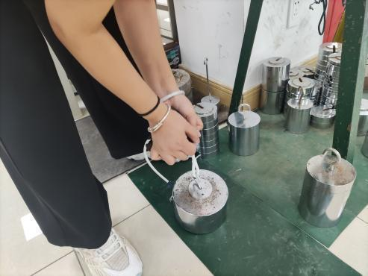 |  | 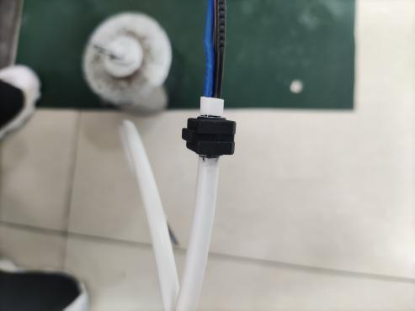
100N, after 25 times, displacement＜2mm
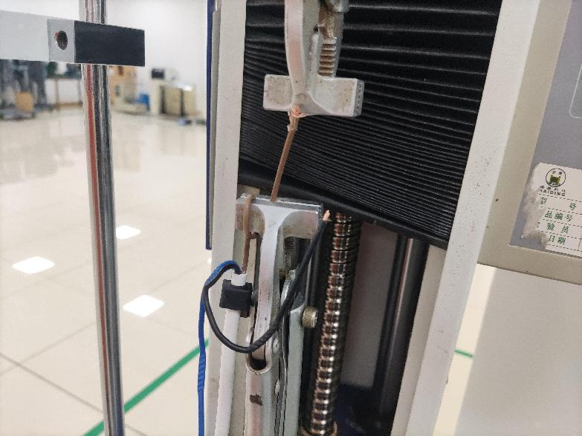 |  | 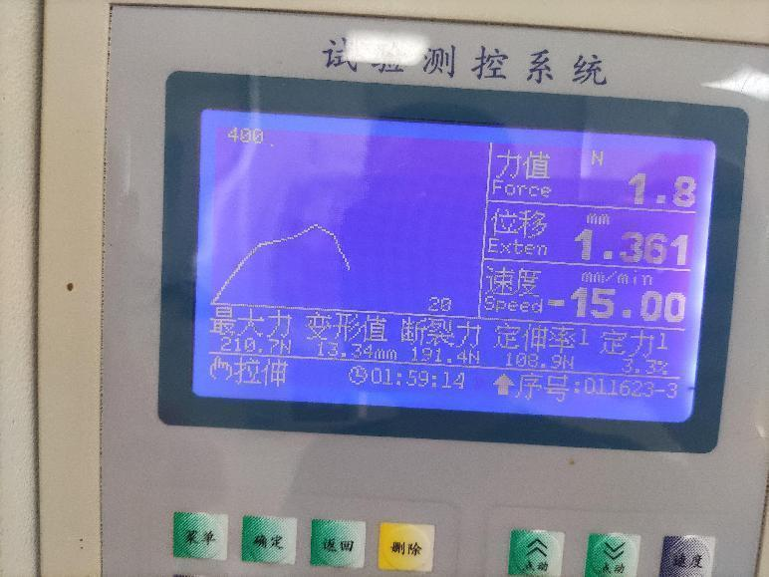
▪Terminal tensile test（Drawing requirement ≥160N）, actual data：210.7N is OK
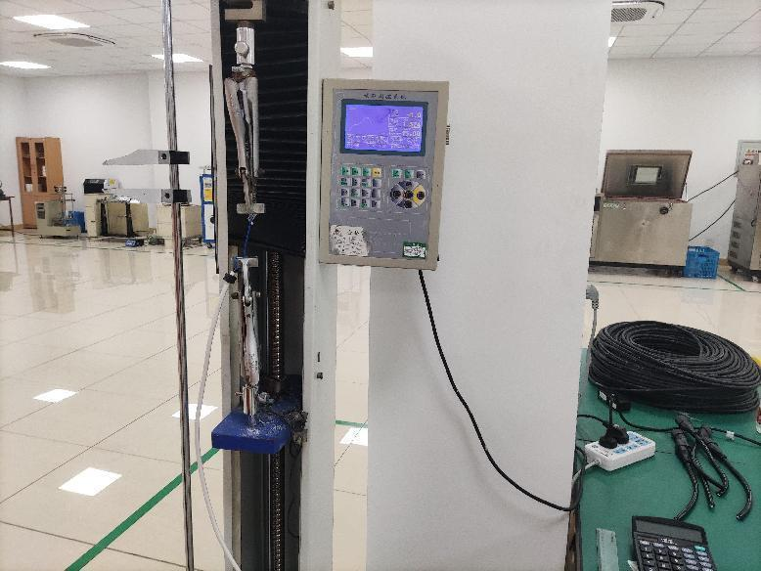 |  | 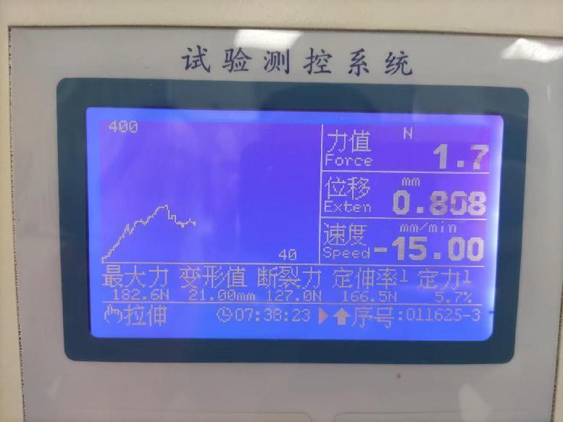
▪Terminal tensile test（Drawing requirement ≥160N）, actual data：182.6N is OK
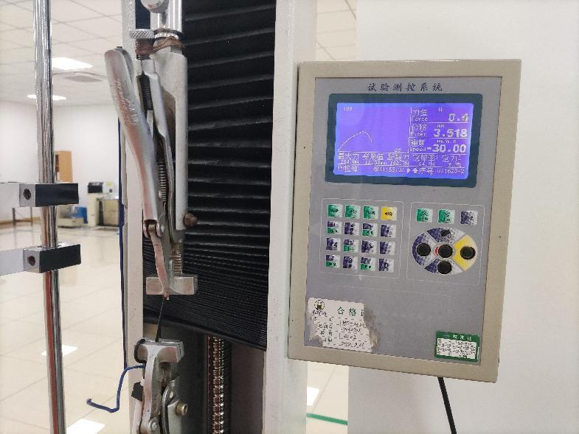 |  | 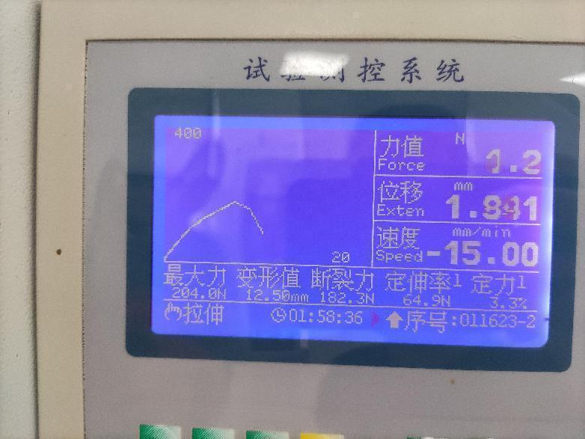
▪Terminal tensile test（Drawing requirement ≥160N）, actual data：204N is OK
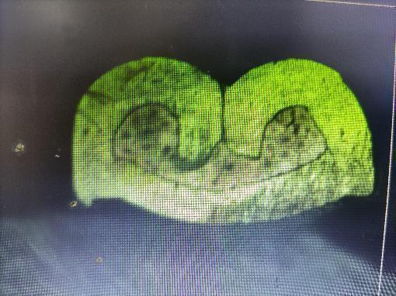 | 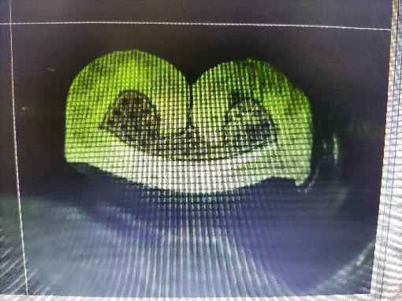 |  | 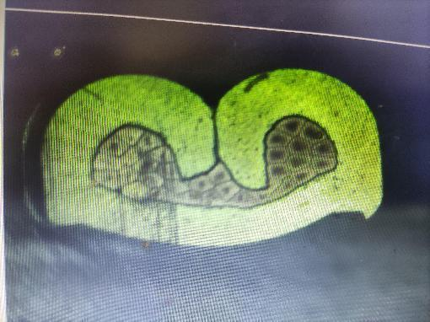
Metallo scope to check copper wire riveting：OK
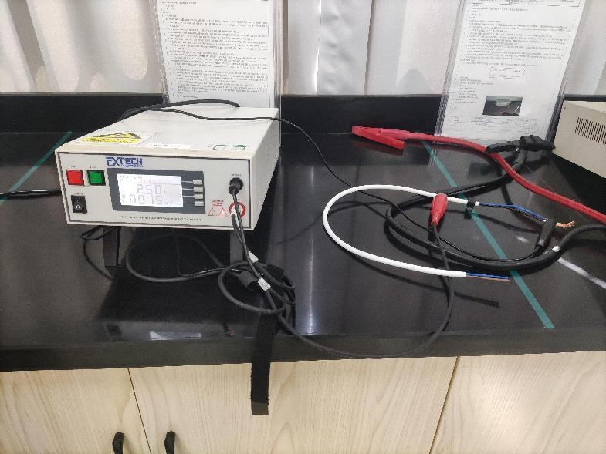 |  | 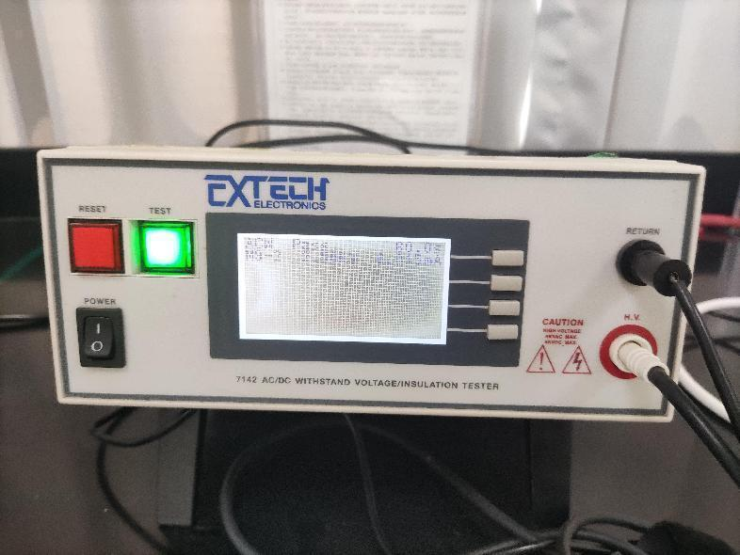
high-voltage examination：2500V/60s OK
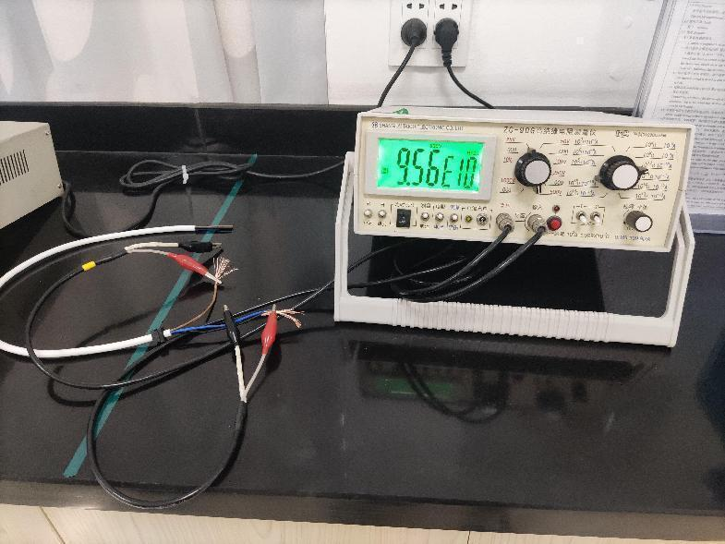 |  | 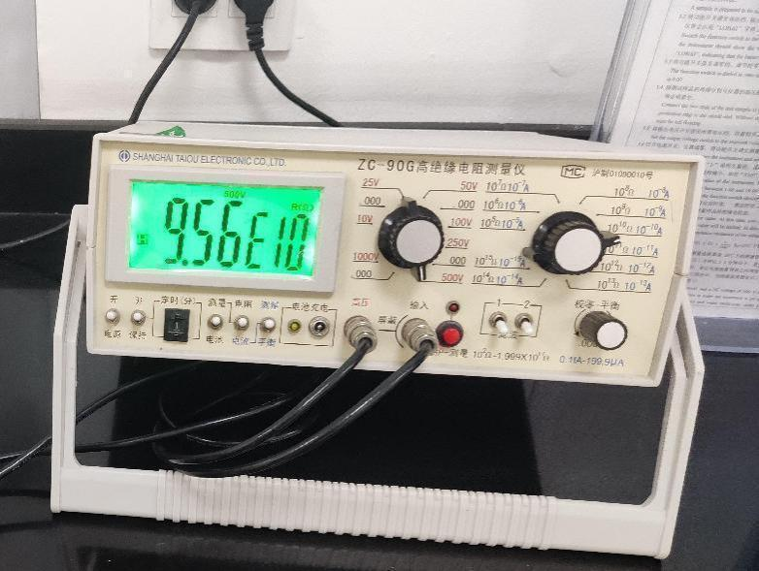
Insulation resistance test＞100MΩ：OK
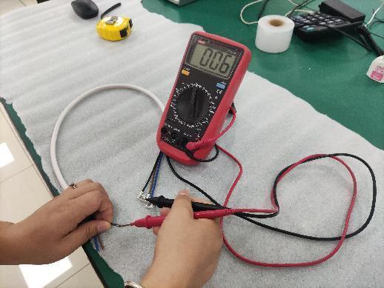 | 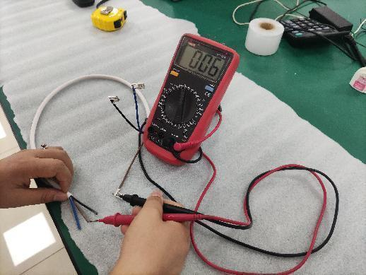 |  | 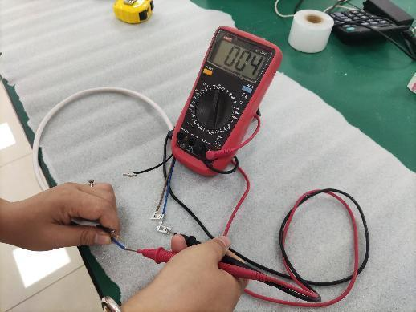
Continuity test ：OK

